Cone
# Source: AI Source: Provided by: [Data Path: Persons Table -> ID Column: 1, Name_En Column: Motasem Essam] -> From: [ChatGPT] on [7/25/2026]
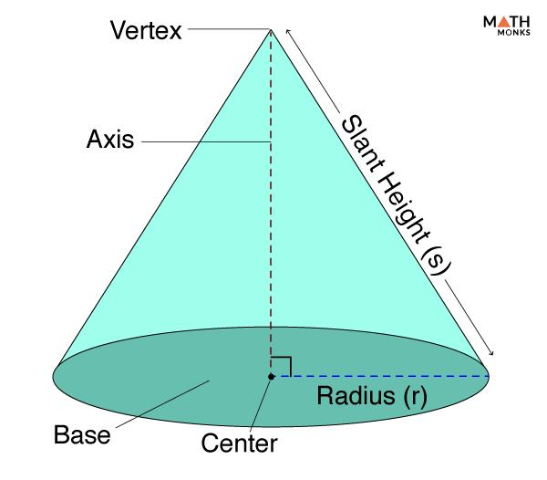
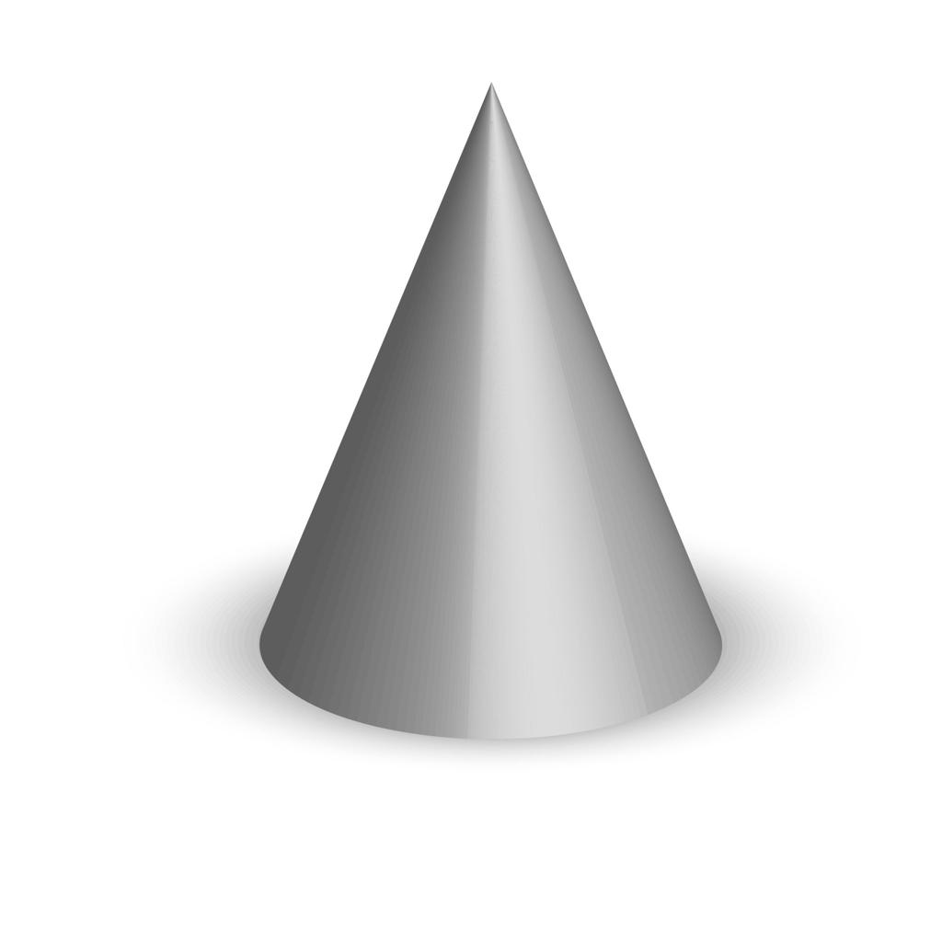
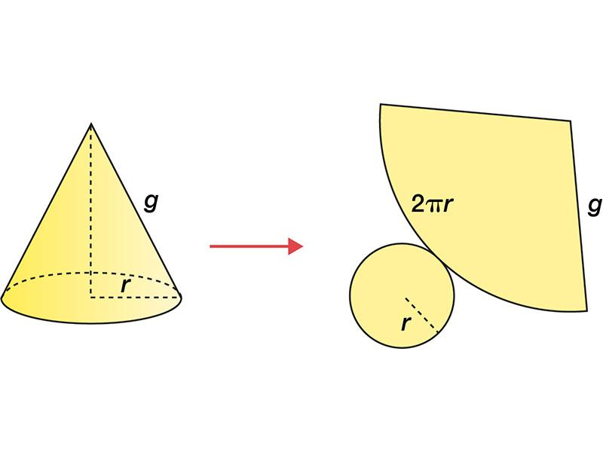

Definition
# Source: AI Source: Provided by: [Data Path: Persons Table -> ID Column: 1, Name_En Column: Motasem Essam] -> From: [ChatGPT] on [7/25/2026]
A cone is a three-dimensional geometric solid with a circular base and a curved lateral surface that narrows toward a point called the apex.
In a right circular cone, the apex lies directly above or below the center of the circular base. The line joining the apex to the base center is perpendicular to the base plane.
A cone has one flat circular base and one curved lateral surface. Its curved surface meets the base along a circular boundary.

Simple Definition
# Source: AI Source: Provided by: [Data Path: Persons Table -> ID Column: 1, Name_En Column: Motasem Essam] -> From: [ChatGPT] on [7/25/2026]
A cone is a three-dimensional solid with a circular base and a curved surface that tapers to a single point.
Examples include an ice-cream cone, a traffic cone, and a funnel's approximate outer shape.

Key Characteristics
# Source: AI Source: Provided by: [Data Path: Persons Table -> ID Column: 1, Name_En Column: Motasem Essam] -> From: [ChatGPT] on [7/25/2026]
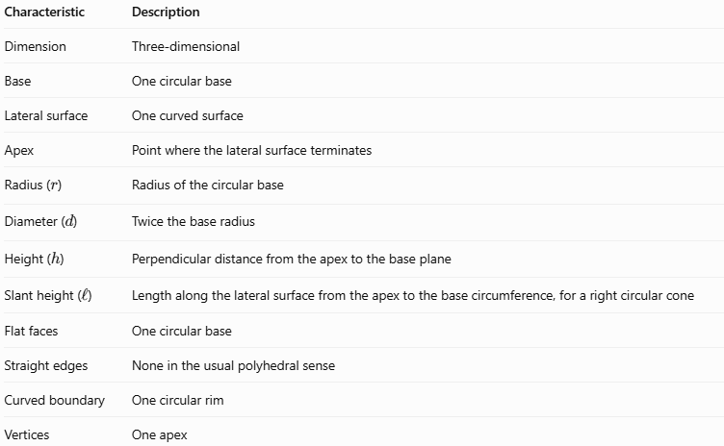
Characteristic | Description
Dimension | Three-dimensional
Base | One circular base
Lateral surface | One curved surface
Apex | Point where the lateral surface terminates
Radius ($r$) | Radius of the circular base
Diameter ($d$) | Twice the base radius
Height ($h$) | Perpendicular distance from the apex to the base plane
Slant height ($l$) | Length along the lateral surface from the apex to the base circumference, for a right circular cone
Flat faces | One circular base
Straight edges | None in the usual polyhedral sense
Curved boundary | One circular rim
Vertices | One apex

Geometric Representation
# Source: AI Source: Provided by: [Data Path: Persons Table -> ID Column: 1, Name_En Column: Motasem Essam] -> From: [ChatGPT] on [7/25/2026]
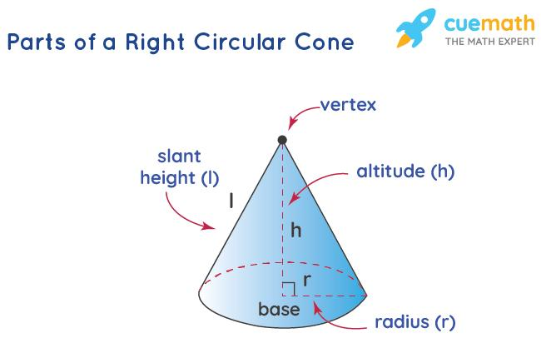
The main components of a cone are:
- Base: The flat circular face.
- Apex: The pointed vertex at the top of the cone.
- Radius ($r$): Distance from the center of the base to its circumference.
- Diameter ($d$): Distance across the circular base through its center.
- Height ($h$): Perpendicular distance from the apex to the base plane.
- Slant height ($l$): Length along the lateral surface from the apex to the base circumference.
- Curved lateral surface: The surface connecting the base circumference to the apex.
- Circular rim: The curved boundary where the base and lateral surface meet.
- Axis: The line joining the apex to the center of the base.
For a right circular cone, the radius, height, and slant height form a right triangle:
$$\boxed{l^{2}=r^{2}+h^{2}}$$
Therefore,
$$\boxed{l=\sqrt{r^{2}+h^{2}}}$$
The diameter and radius are related by:
$$\boxed{d=2r}$$

6. Mathematical Representation and Formulas
# Source: AI Source: Provided by: [Data Path: Persons Table -> ID Column: 1, Name_En Column: Motasem Essam] -> From: [ChatGPT] on [7/25/2026]
The following formulas apply to a right circular cone, unless otherwise stated.

A. Base Area
# Source: AI Source: Provided by: [Data Path: Persons Table -> ID Column: 1, Name_En Column: Motasem Essam] -> From: [ChatGPT] on [7/25/2026]
The base is a circle:
$$\boxed{B=πr^{2}}$$

B. Volume
# Source: AI Source: Provided by: [Data Path: Persons Table -> ID Column: 1, Name_En Column: Motasem Essam] -> From: [ChatGPT] on [7/25/2026]
The volume of a cone is one-third the volume of a cylinder with the same base area and perpendicular height:
$$V=\frac{1}{3}Bh$$
Therefore,
$$\boxed{V=\frac{1}{3}πr^{2}h}$$

C. Curved Surface Area
# Source: AI Source: Provided by: [Data Path: Persons Table -> ID Column: 1, Name_En Column: Motasem Essam] -> From: [ChatGPT] on [7/25/2026]
The curved surface area, also called the lateral surface area, is:
$$\boxed{A_{L}=πrl}$$
Here, $l$ is the slant height, not the perpendicular height.

D. Total Surface Area
# Source: AI Source: Provided by: [Data Path: Persons Table -> ID Column: 1, Name_En Column: Motasem Essam] -> From: [ChatGPT] on [7/25/2026]
For a closed cone, the total surface area includes the curved surface and circular base:
$$A_{T}=A_{L}+B$$
Therefore,
$$\boxed{A_{T}=πrl+πr^{2}}$$
Or equivalently:
$$\boxed{A_{T}=πr\left(l+r\right)}$$

E. Slant Height
# Source: AI Source: Provided by: [Data Path: Persons Table -> ID Column: 1, Name_En Column: Motasem Essam] -> From: [ChatGPT] on [7/25/2026]
Using the Pythagorean theorem:
$$\boxed{l=\sqrt{r^{2}+h^{2}}}$$
This relationship applies to a right circular cone. For an oblique cone, the slant distances from the apex to points on the base circumference are not generally all equal.

F. Cone Net
# Source: AI Source: Provided by: [Data Path: Persons Table -> ID Column: 1, Name_En Column: Motasem Essam] -> From: [ChatGPT] on [7/25/2026]

The net of a right circular cone consists of:
- One circle for the base.
- One circular sector for the curved lateral surface.
The sector's radius is the slant height $l$, and its arc length equals the base circumference $2πr$.

Worked Examples
# Source: AI Source: Provided by: [Data Path: Persons Table -> ID Column: 1, Name_En Column: Motasem Essam] -> From: [ChatGPT] on [7/25/2026]
Example 1: Calculating the Volume
A right circular cone has a radius of $3\text{ cm}$ and a height of $8\text{ cm}$. Find its volume.
Step 1 — Write the formula.
$$V=\frac{1}{3}πr^{2}h$$
Step 2 — Substitute the values.
$$V=\frac{1}{3}{π\left(3\right)}^{2}\left(8\right)$$
$$V=24π$$
Answer:
$$\boxed{V≈75.40{\text{ cm}}^{3}}$$
Example 2: Calculating the Slant Height
A right circular cone has a radius of $5\text{ cm}$ and a height of $12\text{ cm}$. Find its slant height.
Step 1 — Apply the Pythagorean theorem.
$$l=\sqrt{r^{2}+h^{2}}$$
Step 2 — Substitute the values.
$$l=\sqrt{5^{2}+{12}^{2}}$$
$$l=\sqrt{25+144}=\sqrt{169}$$
Answer:
$$\boxed{l=13\text{ cm}}$$
Example 3: Calculating the Curved Surface Area
A right circular cone has a radius of $4\text{ cm}$ and a slant height of $9\text{ cm}$.
$$A_{L}=πrl$$
$$A_{L}=π\left(4\right)\left(9\right)=36π$$
Answer:
$$\boxed{A_{L}≈113.10{\text{ cm}}^{2}}$$
Example 4: Calculating the Total Surface Area
A right circular cone has a radius of $3\text{ cm}$ and a slant height of $5\text{ cm}$.
Step 1 — Write the formula.
$$A_{T}=πr\left(l+r\right)$$
Step 2 — Substitute the values.
$$A_{T}=π\left(3\right)\left(5+3\right)=24π$$
Answer:
$$\boxed{A_{T}≈75.40{\text{ cm}}^{2}}$$

Constructing a Cone

Geometric Instruments
# Source: AI Source: Provided by: [Data Path: Persons Table -> ID Column: 1, Name_En Column: Motasem Essam] -> From: [ChatGPT] on [7/25/2026]
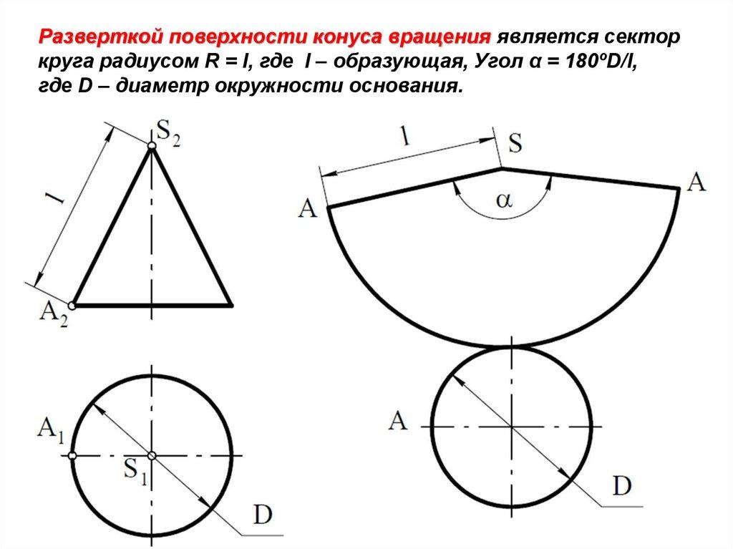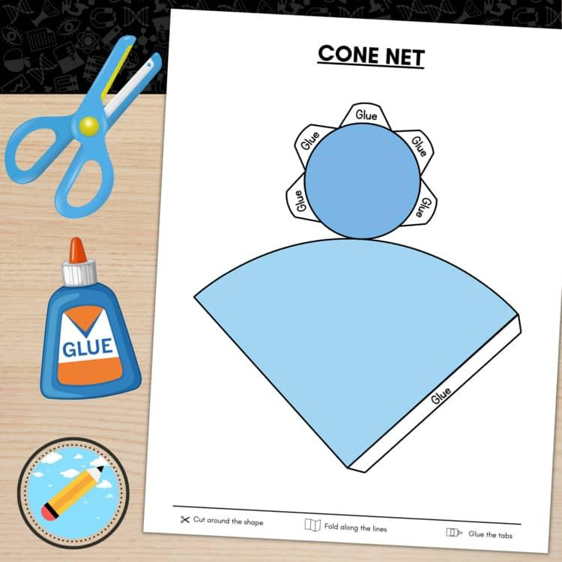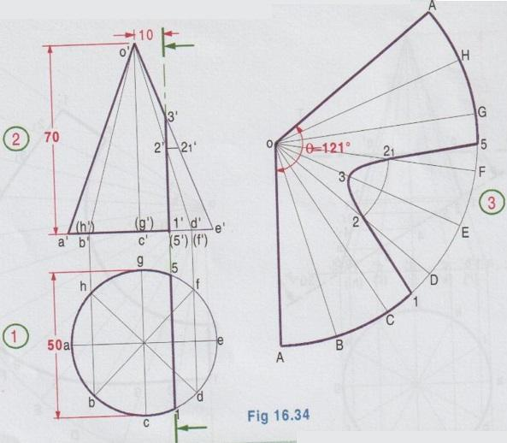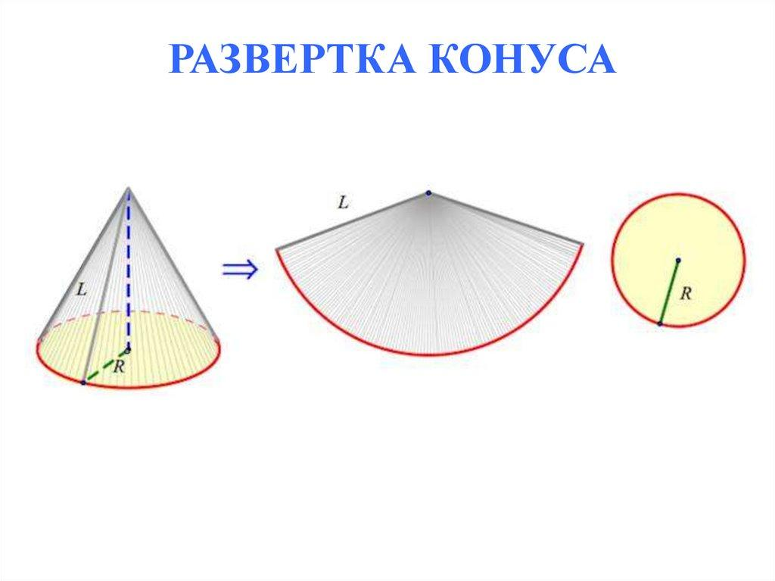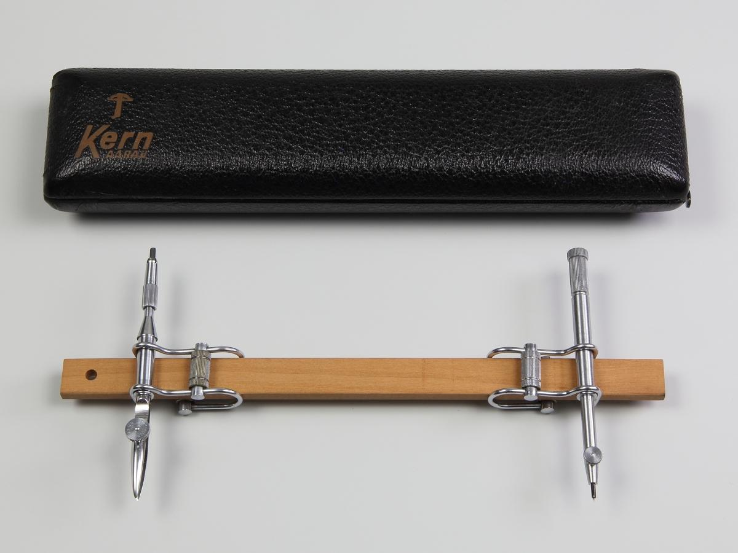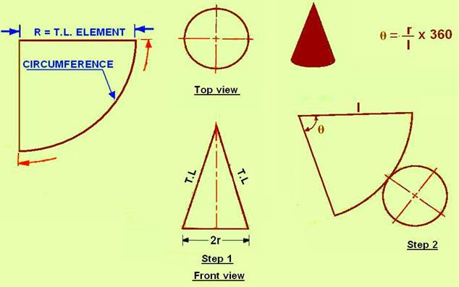
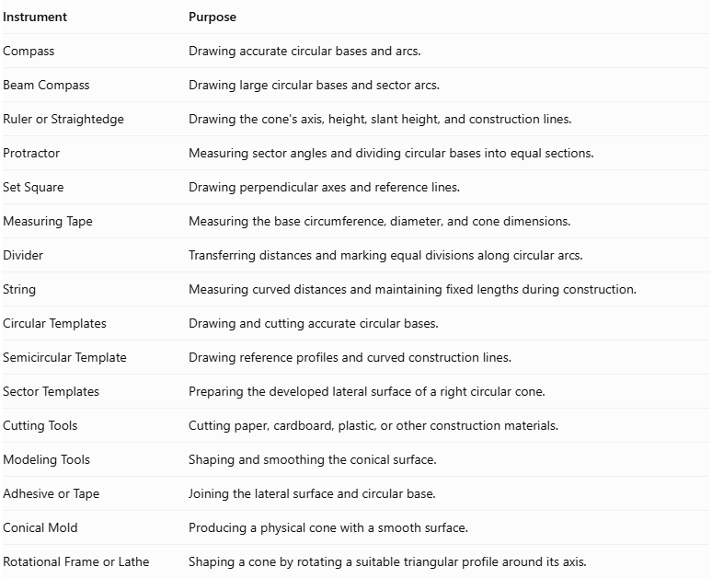
Instrument | Purpose
Compass | Drawing accurate circular bases and arcs.
Beam Compass | Drawing large circular bases and sector arcs.
Ruler or Straightedge | Drawing the cone's axis, height, slant height, and construction lines.
Protractor | Measuring sector angles and dividing circular bases into equal sections.
Set Square | Drawing perpendicular axes and reference lines.
Measuring Tape | Measuring the base circumference, diameter, and cone dimensions.
Divider | Transferring distances and marking equal divisions along circular arcs.
String | Measuring curved distances and maintaining fixed lengths during construction.
Circular Templates | Drawing and cutting accurate circular bases.
Semicircular Template | Drawing reference profiles and curved construction lines.
Sector Templates | Preparing the developed lateral surface of a right circular cone.
Cutting Tools | Cutting paper, cardboard, plastic, or other construction materials.
Modeling Tools | Shaping and smoothing the conical surface.
Adhesive or Tape | Joining the lateral surface and circular base.
Conical Mold | Producing a physical cone with a smooth surface.
Rotational Frame or Lathe | Shaping a cone by rotating a suitable triangular profile around its axis.

Instrument-Based Construction Procedures

Method 1: Constructing a Right Circular Cone Using a Circular Base and Sector
# Source: AI Source: Provided by: [Data Path: Persons Table -> ID Column: 1, Name_En Column: Motasem Essam] -> From: [ChatGPT] on [7/25/2026]
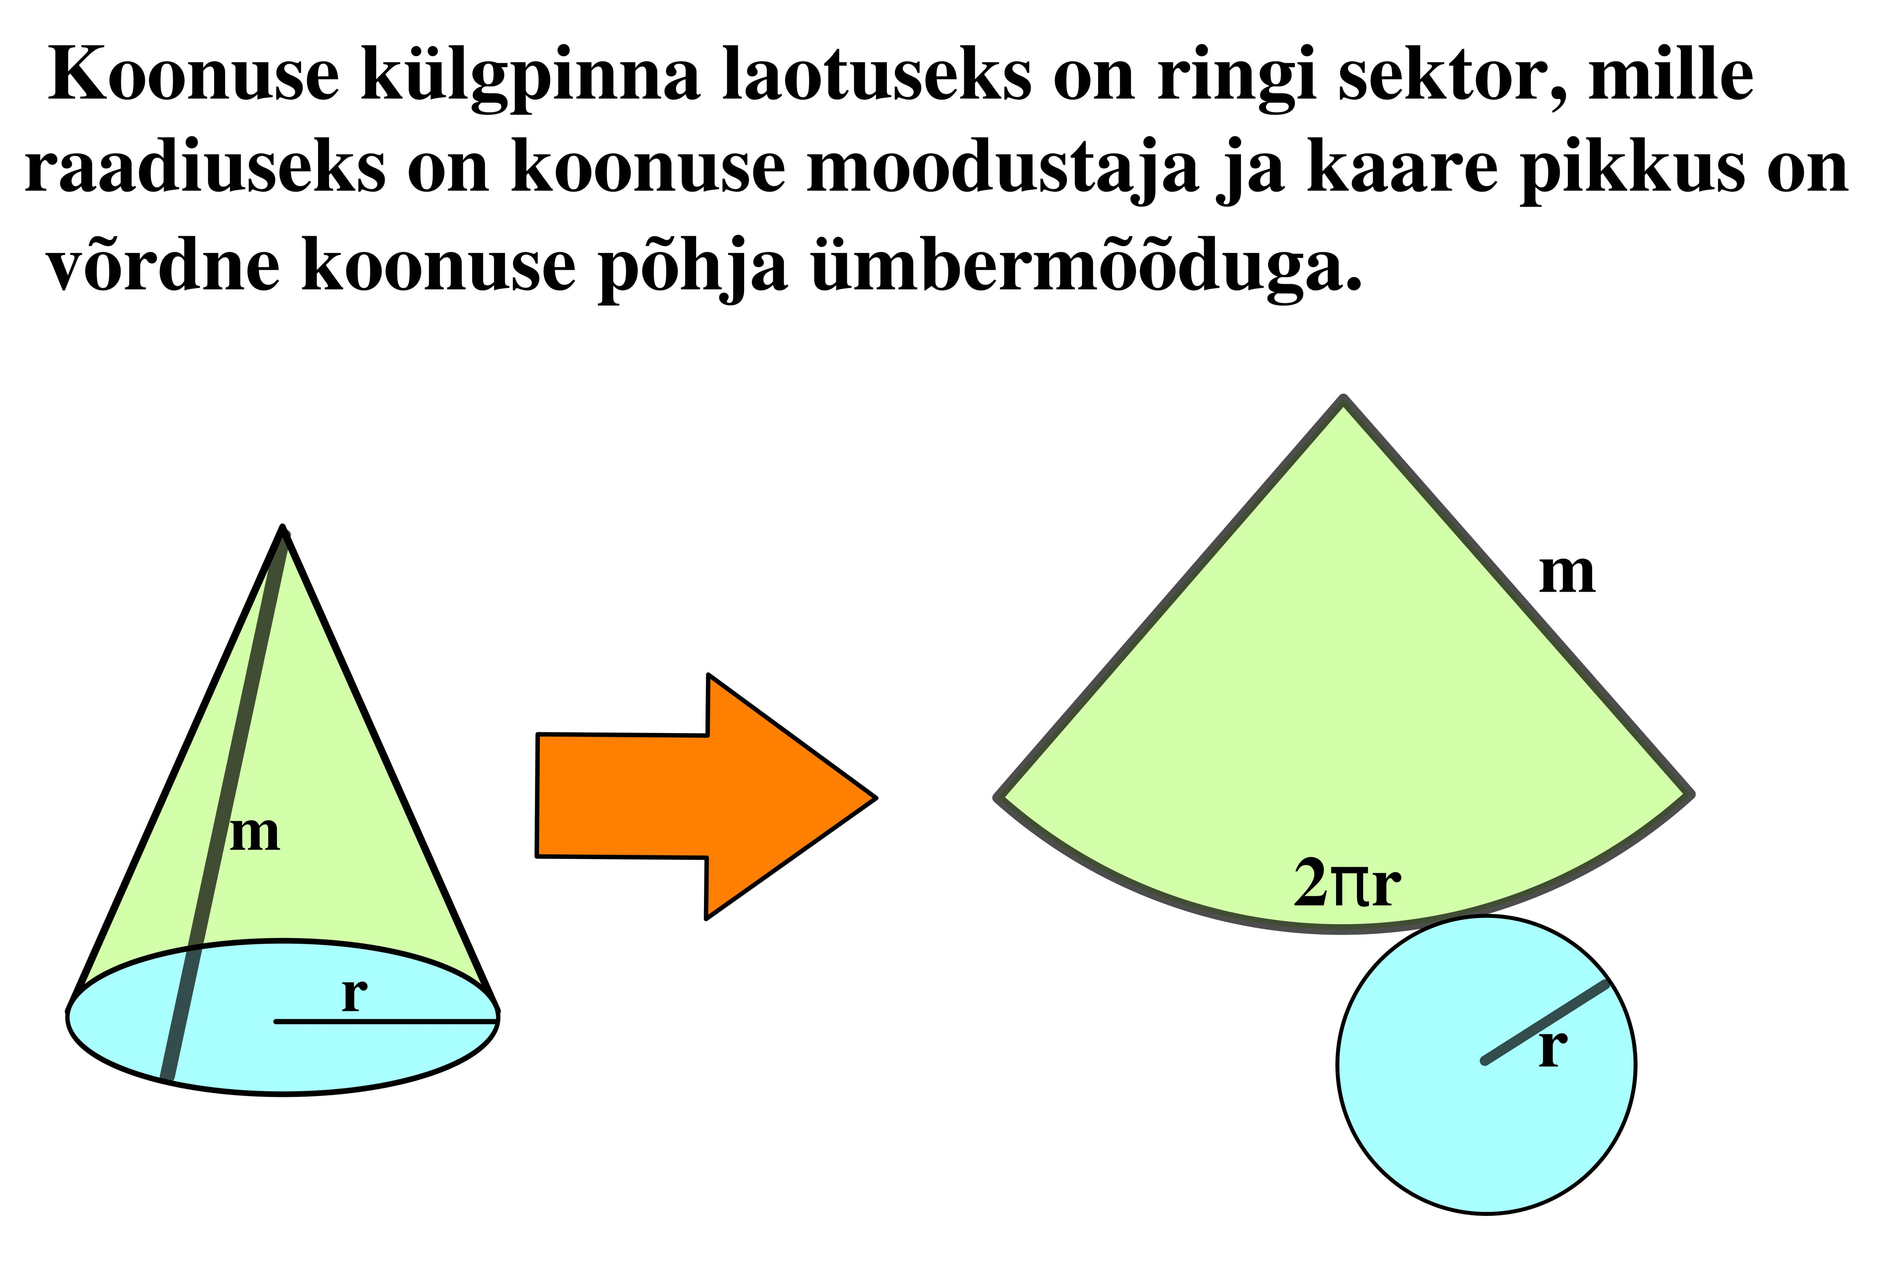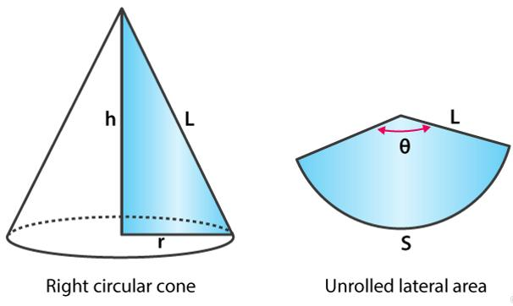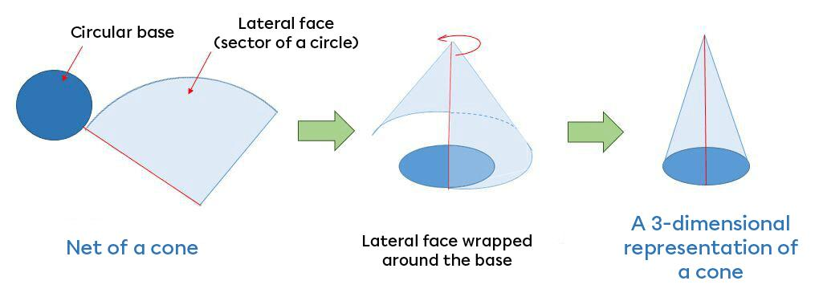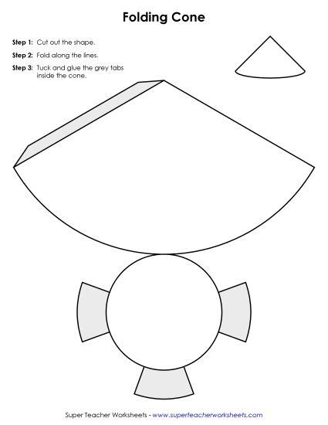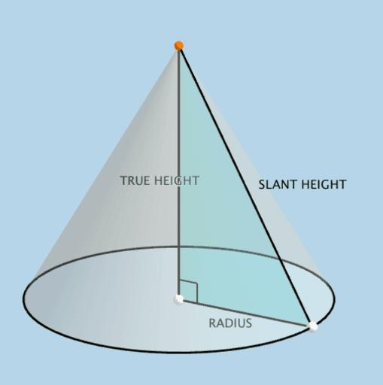
- Determine the required base radius $r$ and perpendicular height $h$.
- Calculate the slant height $s$:
$$s=\sqrt{r^{2}+h^{2}}$$
- Draw a circle with radius $r$ using a compass.
- Calculate the required sector angle:
$$θ=\frac{r}{s}×{360}^{°}$$
- Mark the sector's center using a ruler.
- Set the compass opening to the slant height $s$.
- Draw an arc with radius $s$.
- Use a protractor to mark the sector angle $θ$.
- Draw the two radial boundaries from the sector's center to the arc endpoints.
- Cut out the circular base and sector.
- Roll the sector until its two radial edges meet.
- Join the edges using adhesive or tape.
- Attach the circular base to the bottom opening.
- Verify the cone's base radius, height, and slant height.
The sector's radius equals the cone's slant height, and its arc length equals the circumference of the circular base.

Method 2: Constructing a Right Circular Cone Using a Rotational Profile
# Source: AI Source: Provided by: [Data Path: Persons Table -> ID Column: 1, Name_En Column: Motasem Essam] -> From: [ChatGPT] on [7/25/2026]
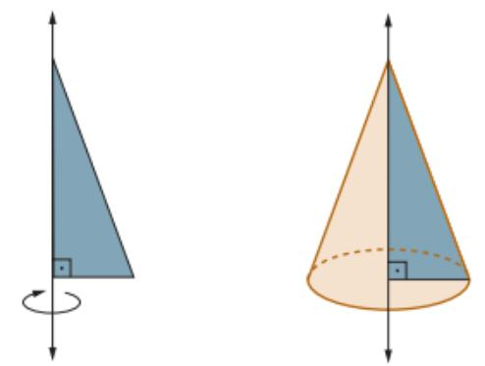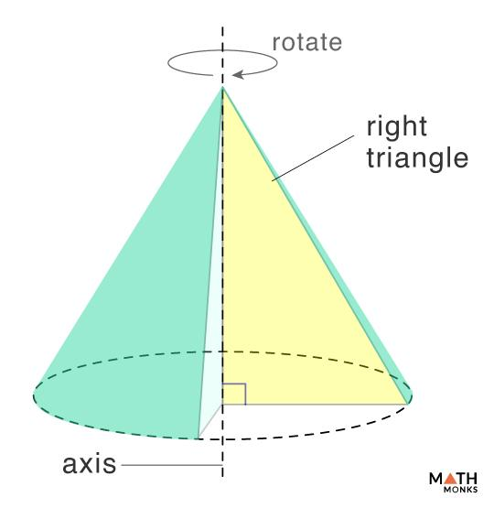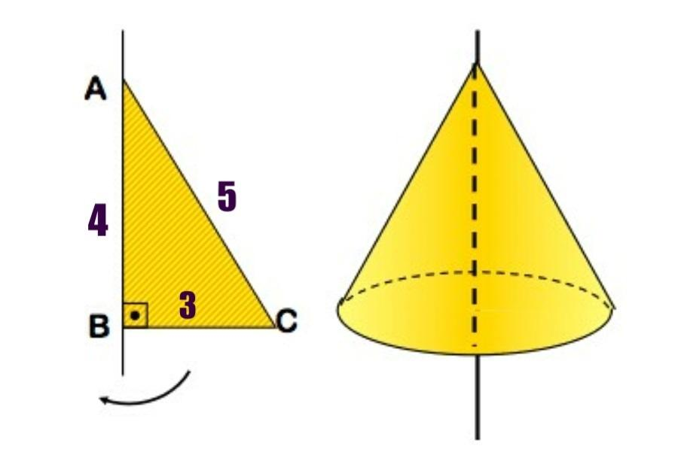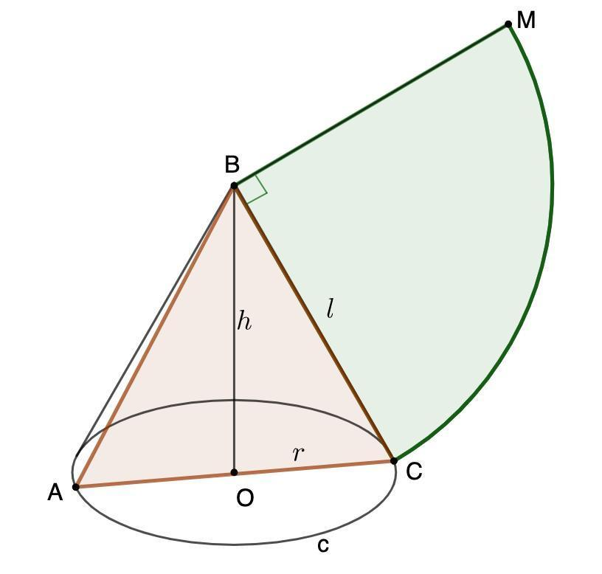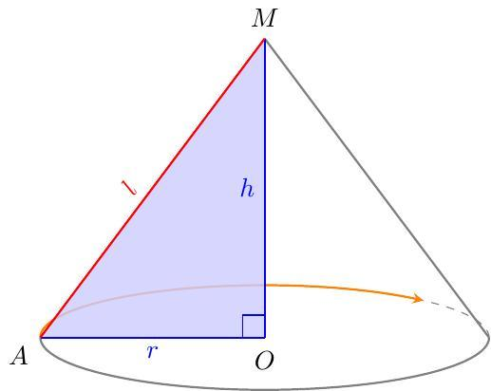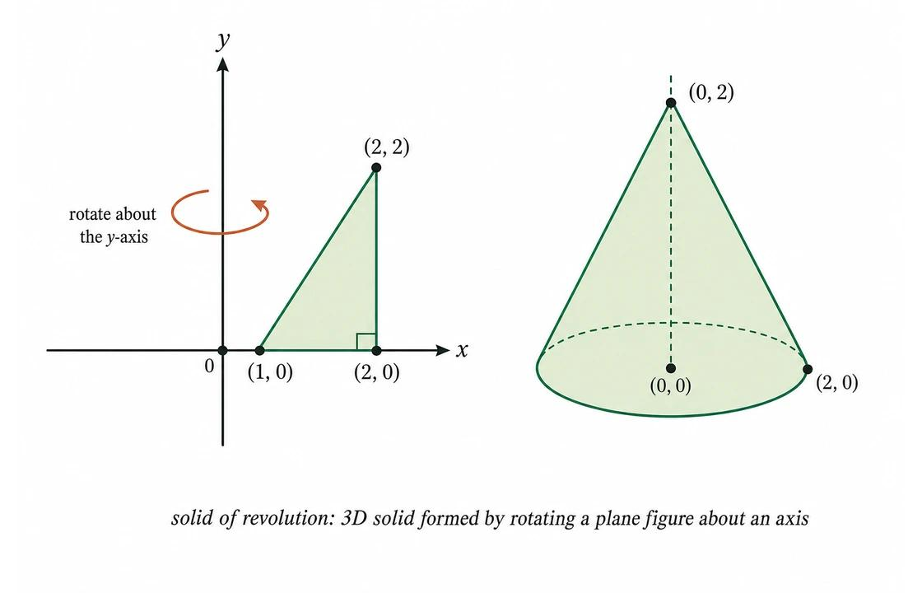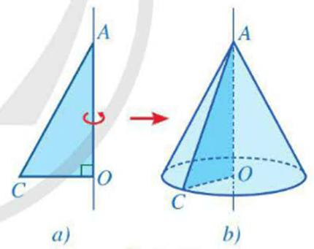
- Determine the required base radius $r$ and height $h$.
- Draw a vertical line segment representing the cone's height.
- Draw a perpendicular line segment at its lower endpoint representing the base radius.
- Connect the upper endpoint of the height to the outer endpoint of the radius.
- The resulting right triangle represents the cone's axial cross-section.
- Cut the triangular profile from cardboard, plastic, or another suitable material.
- Attach the profile to a rotational frame along its height side.
- Rotate the triangular profile through a complete ${360}^{°}$ revolution around the height axis.
- Observe the resulting three-dimensional conical surface.
- Use the rotating profile as a guide to shape a physical cone.
- Smooth the lateral surface and verify its dimensions.

Method 3: Constructing a Cone Using Circular Cross-Sections
# Source: AI Source: Provided by: [Data Path: Persons Table -> ID Column: 1, Name_En Column: Motasem Essam] -> From: [ChatGPT] on [7/25/2026]
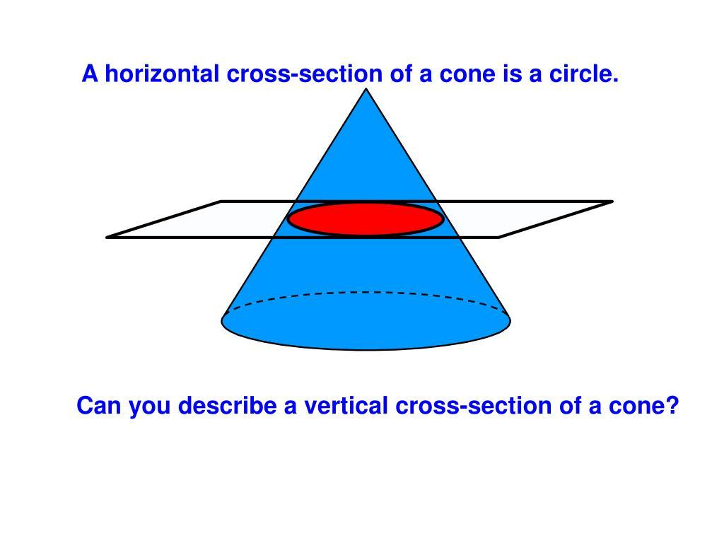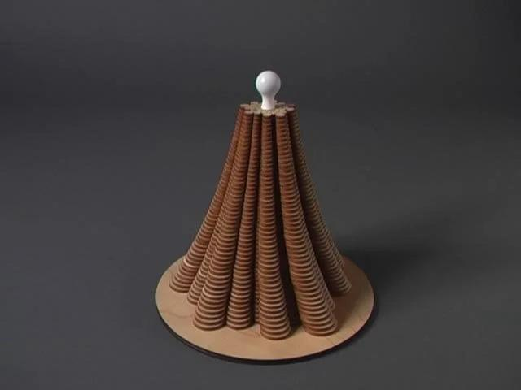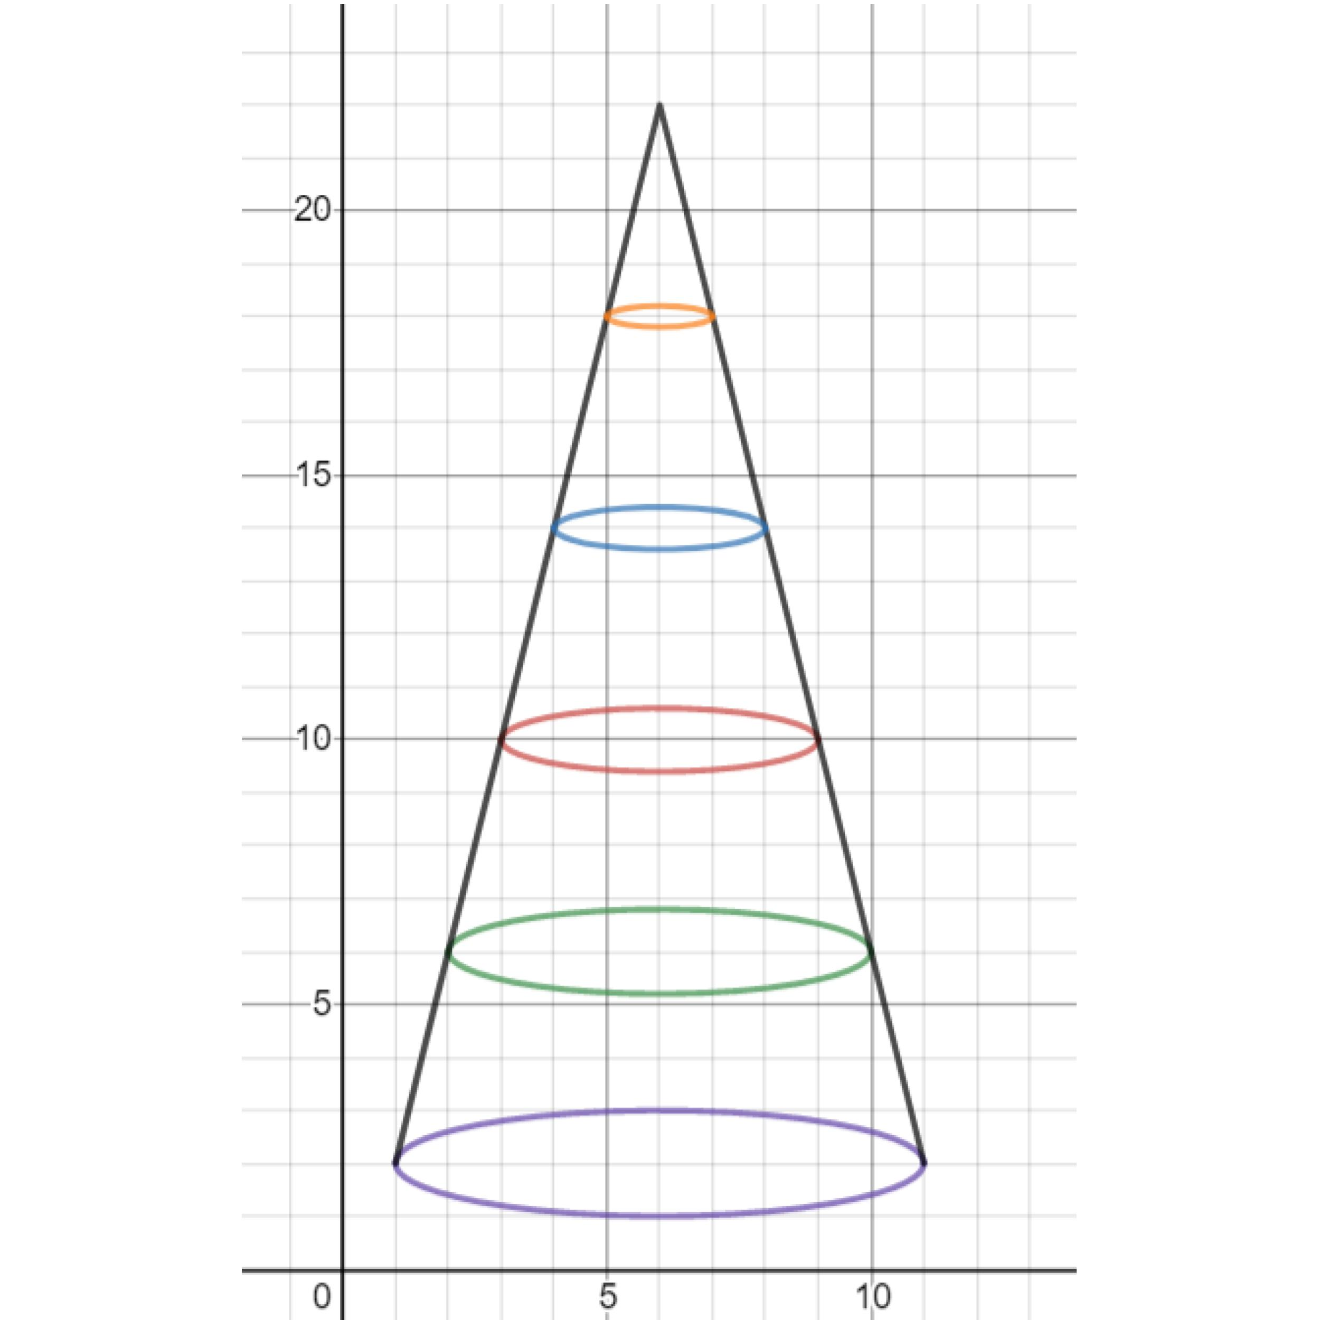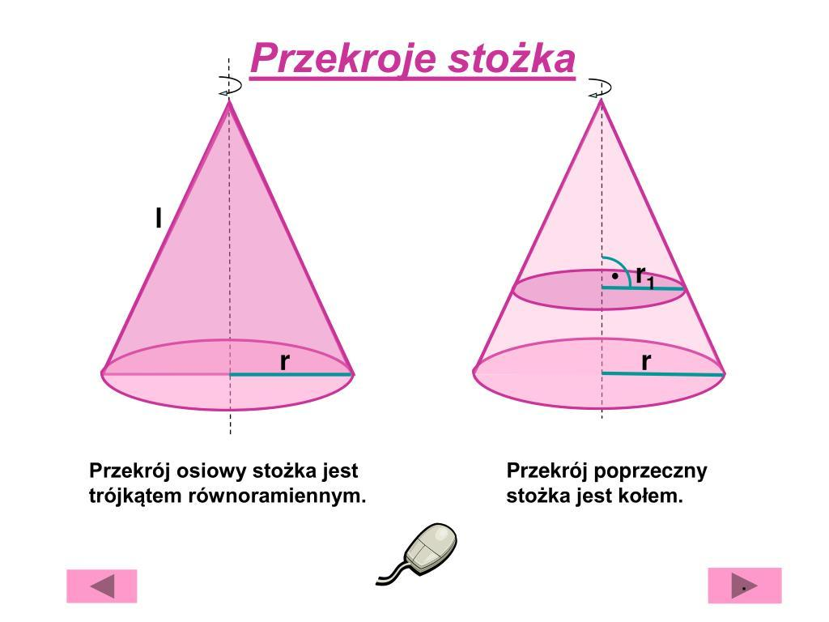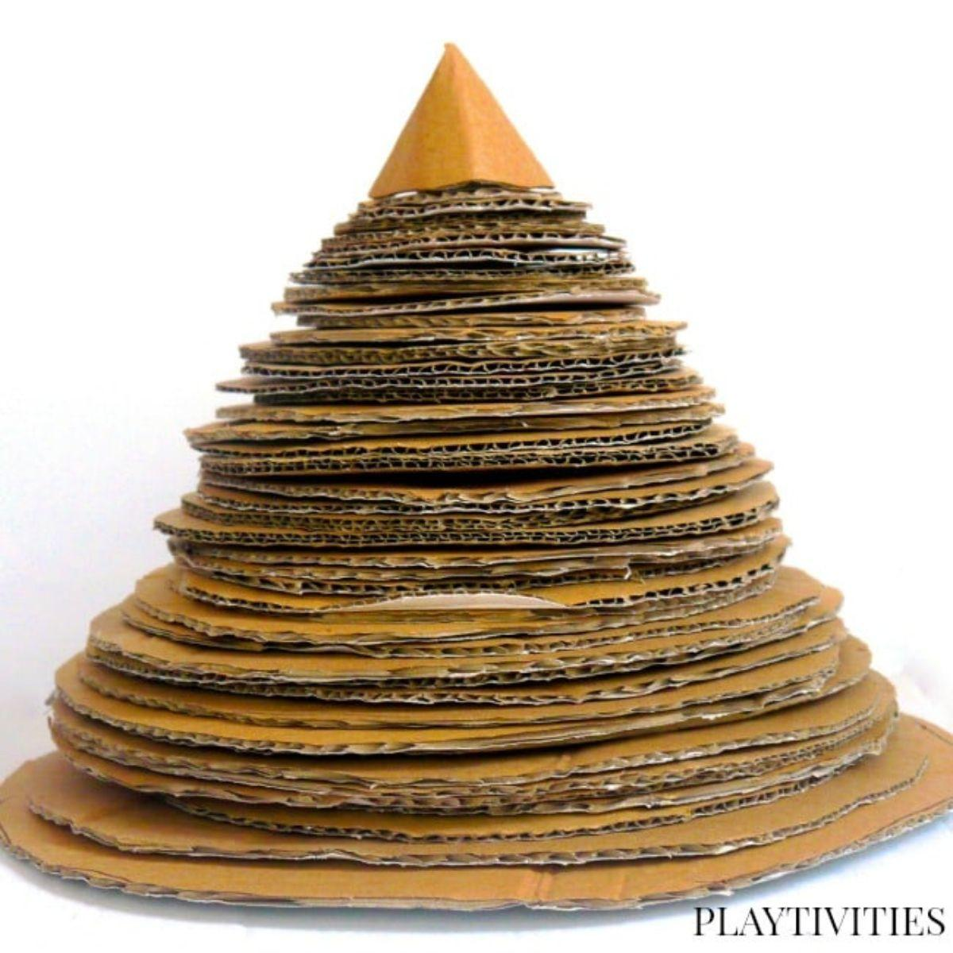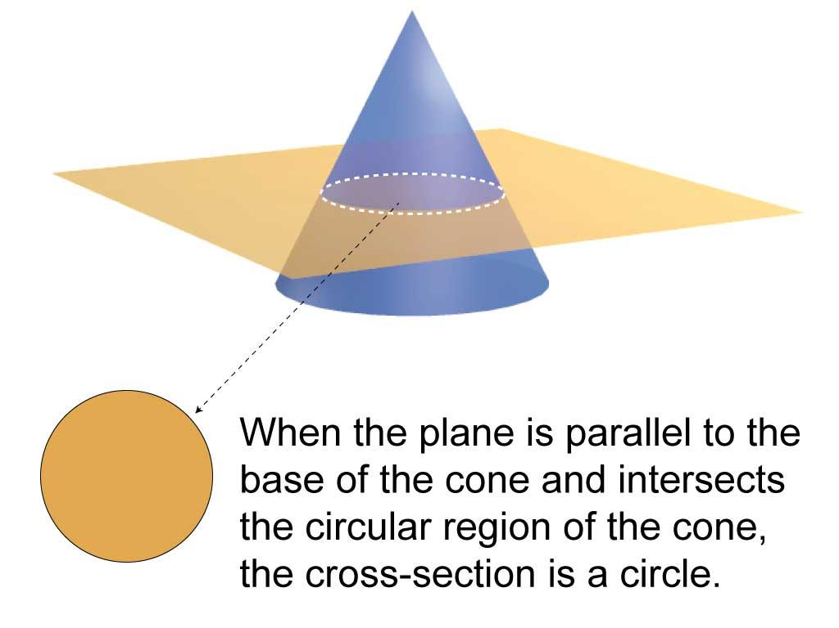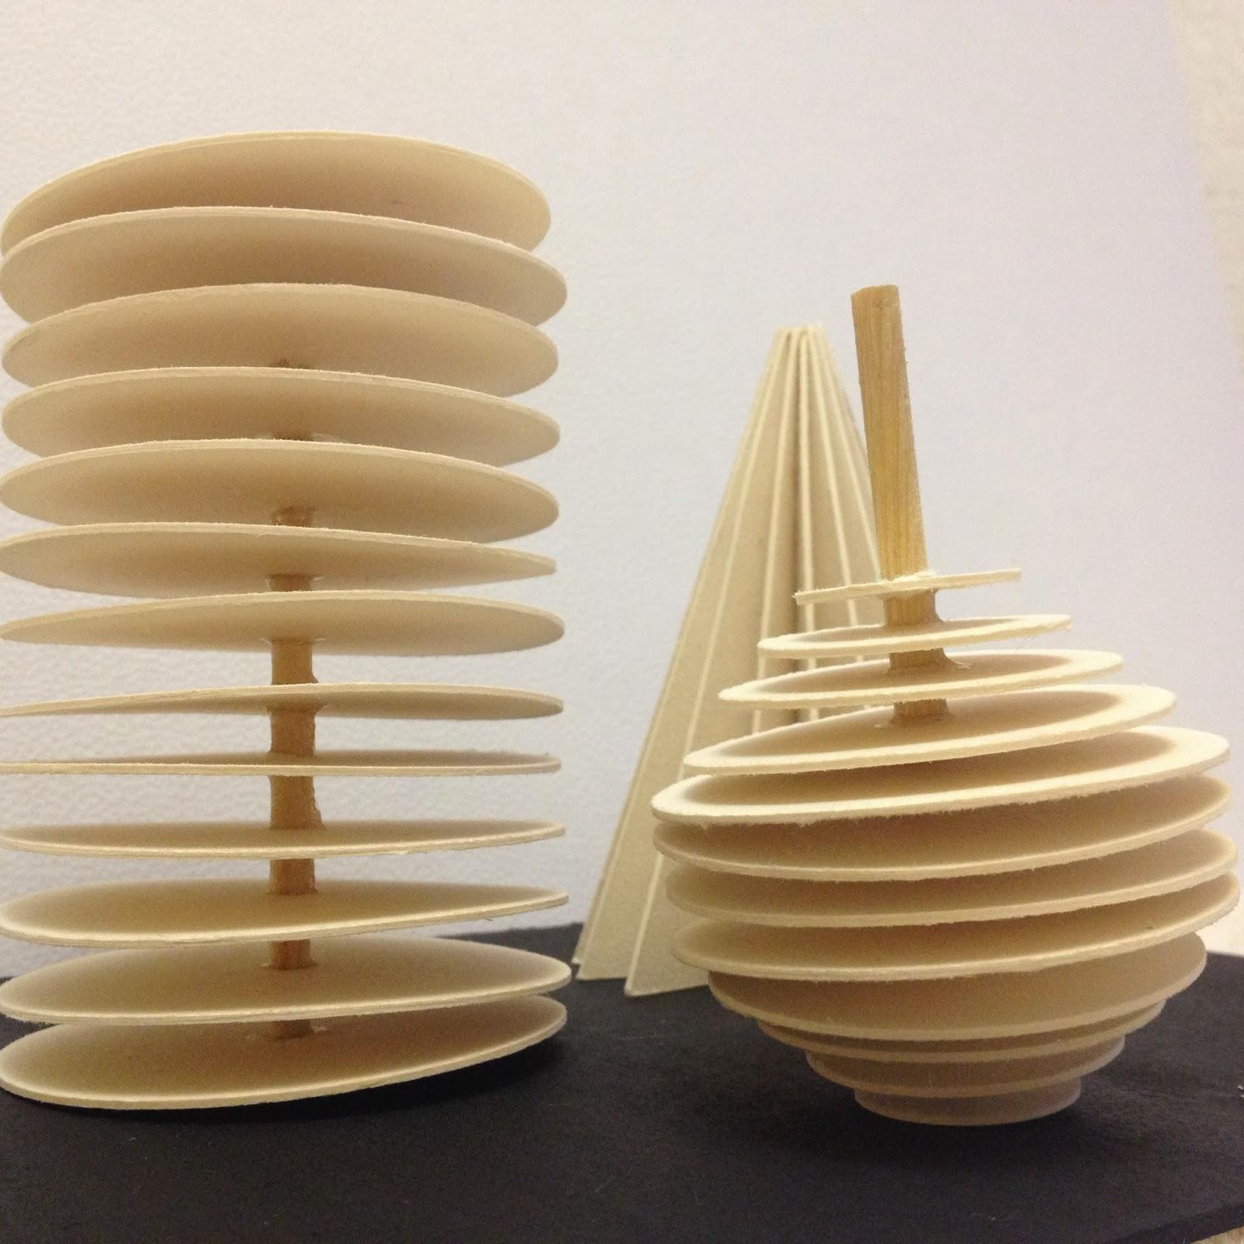
- Determine the required cone radius $r$ and height $h$.
- Draw a vertical axis representing the cone's height.
- Mark the apex and base center along the same axis.
- Divide the height into several equal intervals using a ruler.
- Draw perpendicular reference lines through the division points using a set square.
- Determine the radius of each circular cross-section according to its distance from the apex.
- Draw the corresponding circles using a compass or circular templates.
- Cut the circular sections from cardboard, foam, or another suitable material.
- Arrange the circles perpendicular to the central axis.
- Align their centers along the axis.
- Arrange the largest circle at the base and progressively smaller circles toward the apex.
- Join the sections and smooth their outer boundaries to approximate a continuous conical surface.

Method 4: Constructing an Oblique Circular Cone
# Source: AI Source: Provided by: [Data Path: Persons Table -> ID Column: 1, Name_En Column: Motasem Essam] -> From: [ChatGPT] on [7/25/2026]
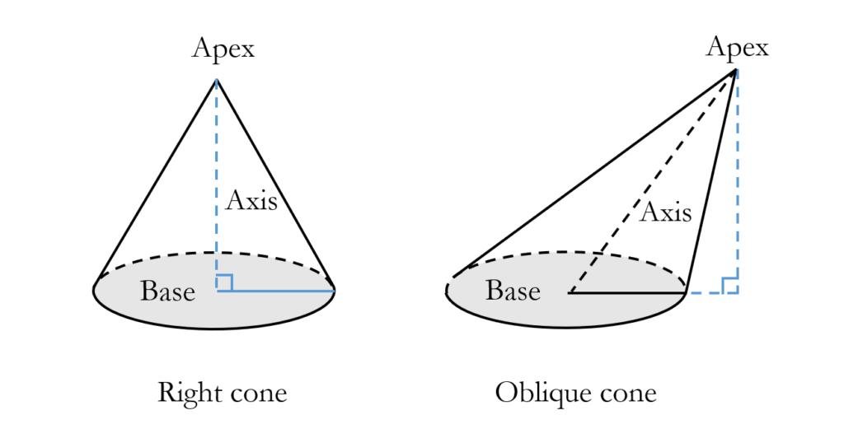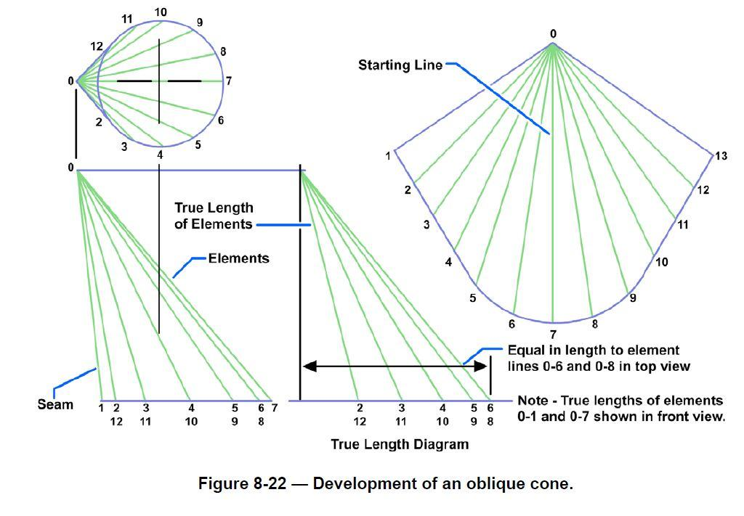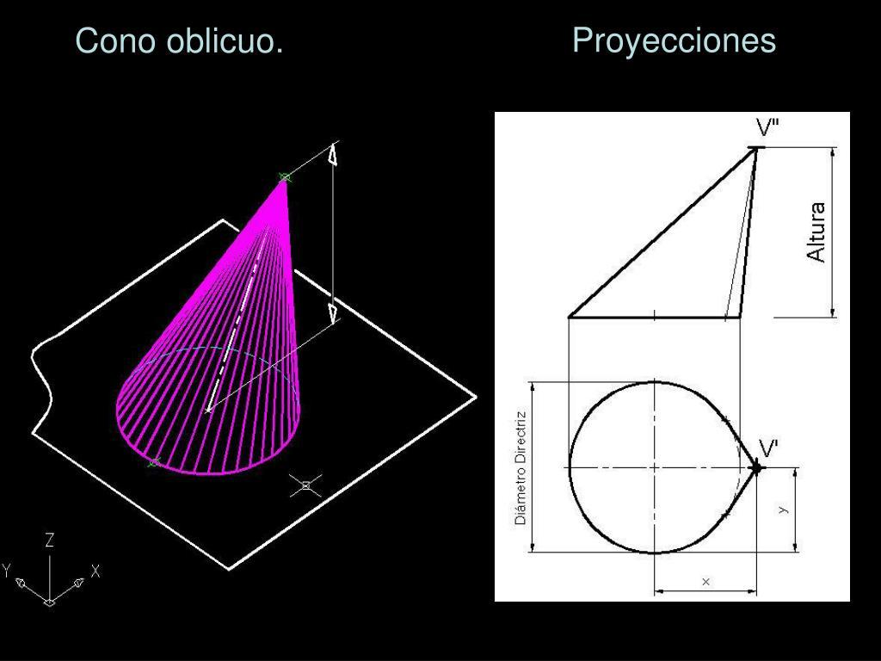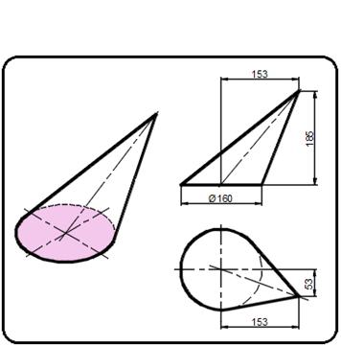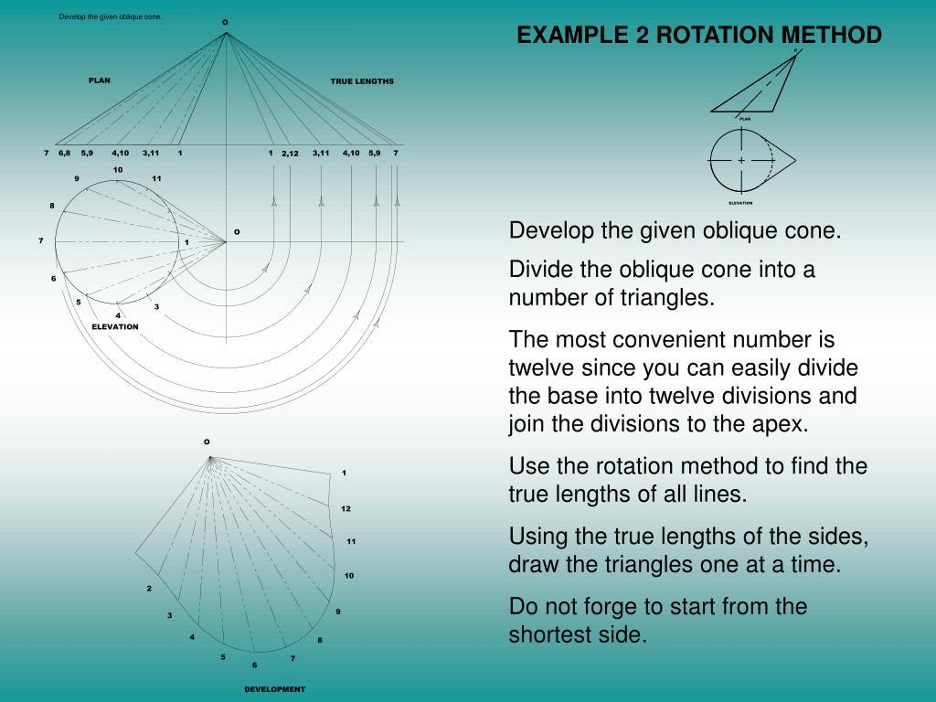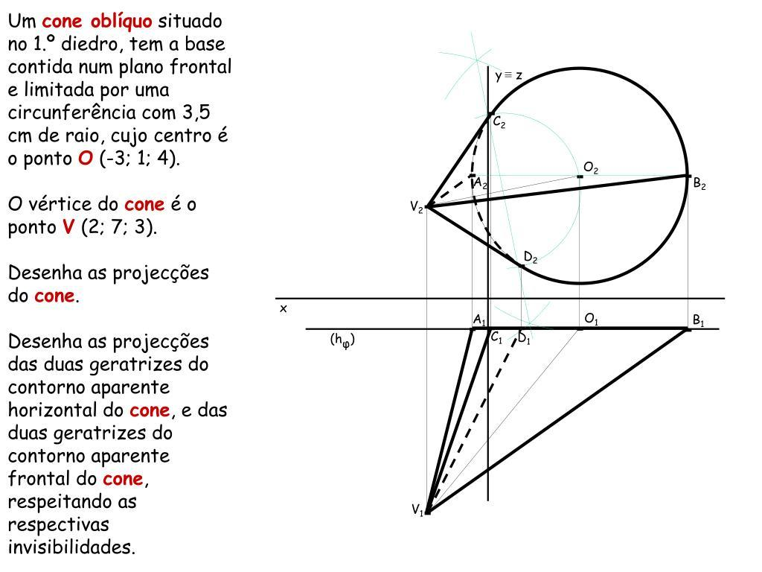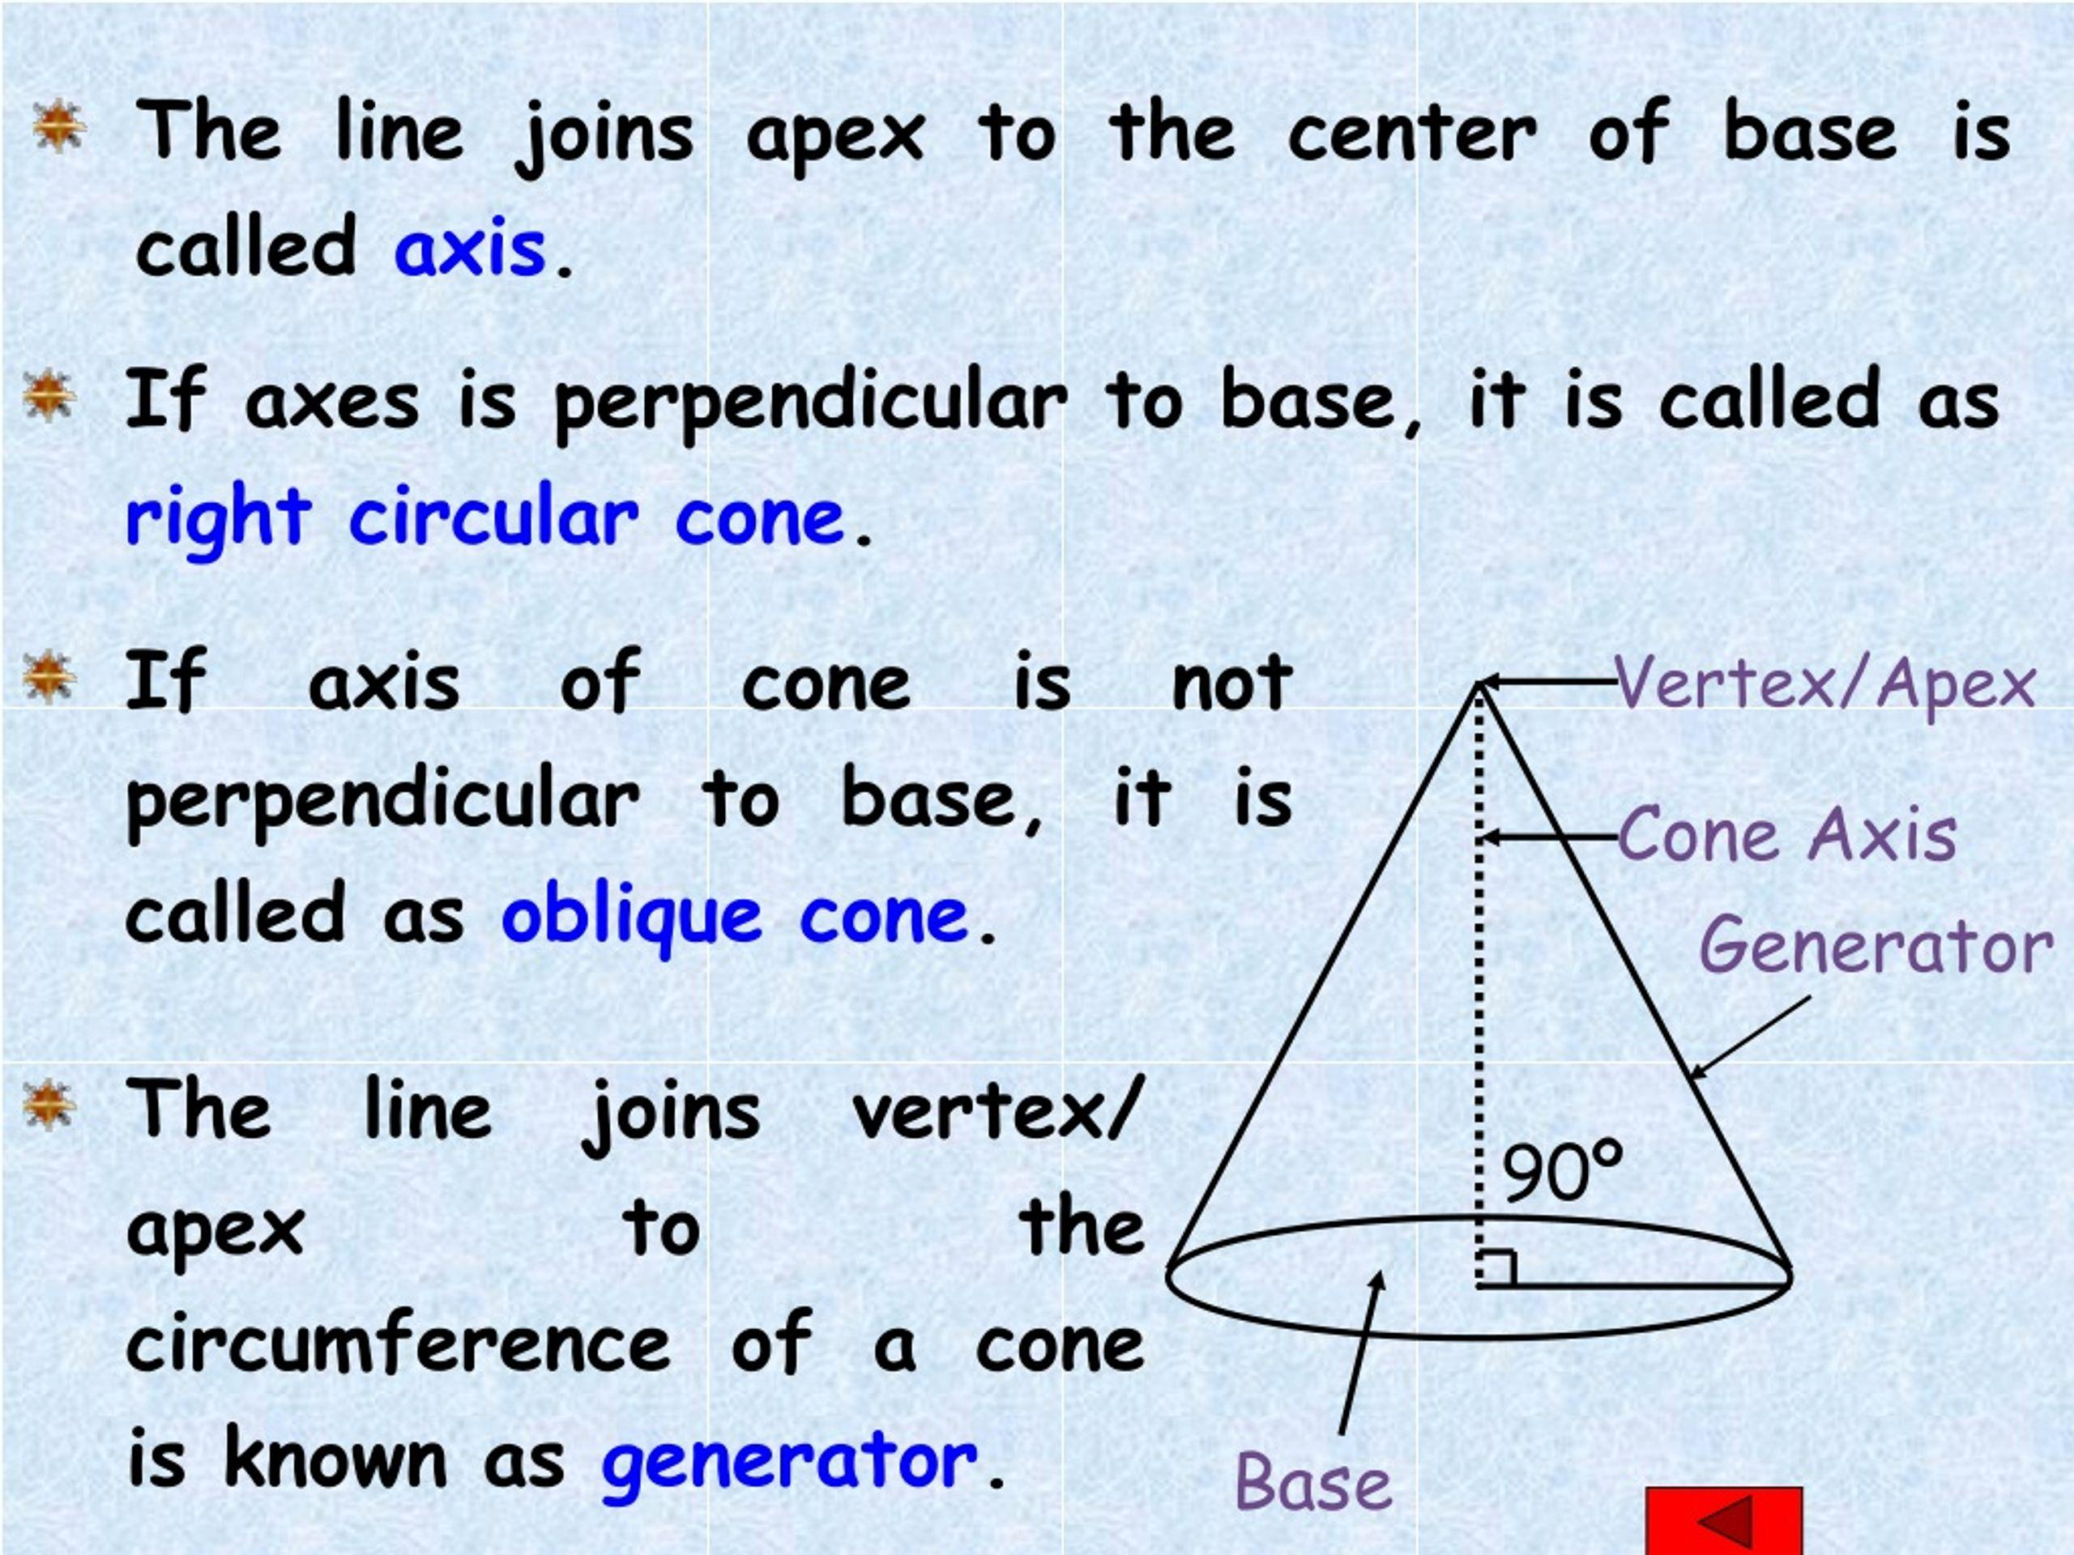
- Determine the required base radius and the position of the apex.
- Draw the circular base using a compass.
- Mark the base center and the intended apex position.
- Position the apex away from the perpendicular line passing through the base center to establish an inclined axis.
- Divide the circular base into 12 or more equal sections using a protractor.
- Draw straight construction lines connecting the apex to each division point on the base circumference.
- Determine the true length of each lateral element using appropriate ruler-based geometric constructions.
- Prepare a radial development using the measured true lengths.
- Draw the lateral development by connecting the apex to the corresponding developed base points.
- Cut the developed lateral pattern and circular base.
- Fold or shape the lateral pattern into the oblique conical surface.
- Attach the circular base and verify the inclined position of the apex.
Note: Unlike a right circular cone, an oblique cone has lateral elements of different lengths, so its development is not generally a simple circular sector.

Method 5: Constructing a Cone Using a Circular Template and Conical Mold
# Source: AI Source: Provided by: [Data Path: Persons Table -> ID Column: 1, Name_En Column: Motasem Essam] -> From: [ChatGPT] on [7/25/2026]
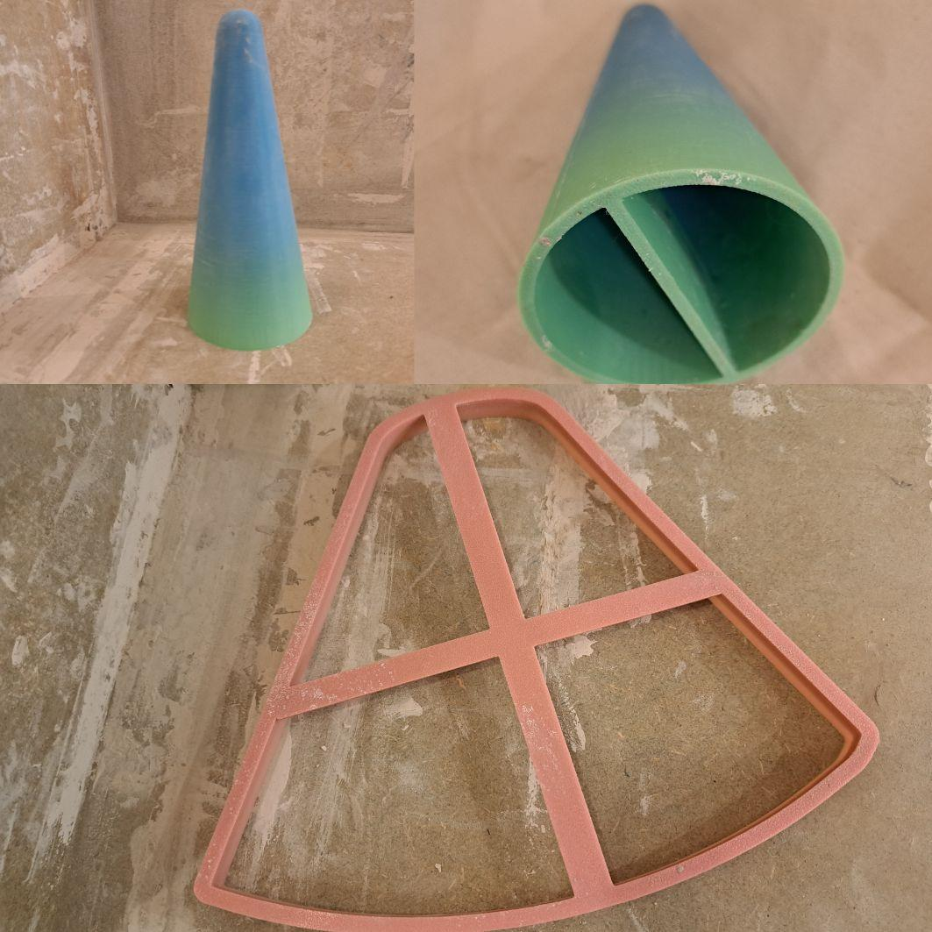
- Determine the required base radius and height.
- Prepare a conical mold with the required dimensions.
- Verify the base diameter and height using measuring instruments.
- Check that the mold's lateral surface follows the intended conical profile.
- Position the mold securely.
- Prepare a suitable modeling material.
- Fill the mold with the material, ensuring that it occupies the intended conical space.
- Allow the material to set or harden.
- Remove the cone from the mold, if the mold is designed to be removable.
- Smooth the lateral surface and circular base.
- Measure the finished cone to verify its dimensions.

Method 6: Constructing a Cone Using a Radial-Line Development
# Source: AI Source: Provided by: [Data Path: Persons Table -> ID Column: 1, Name_En Column: Motasem Essam] -> From: [ChatGPT] on [7/25/2026]
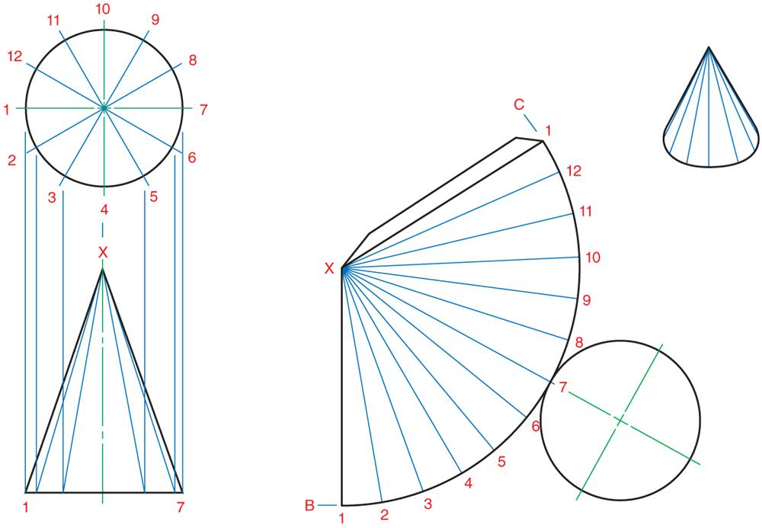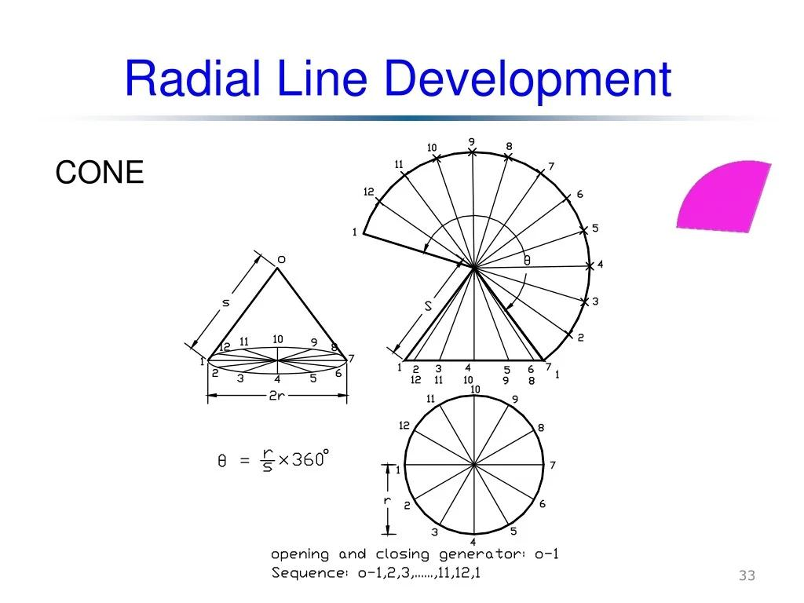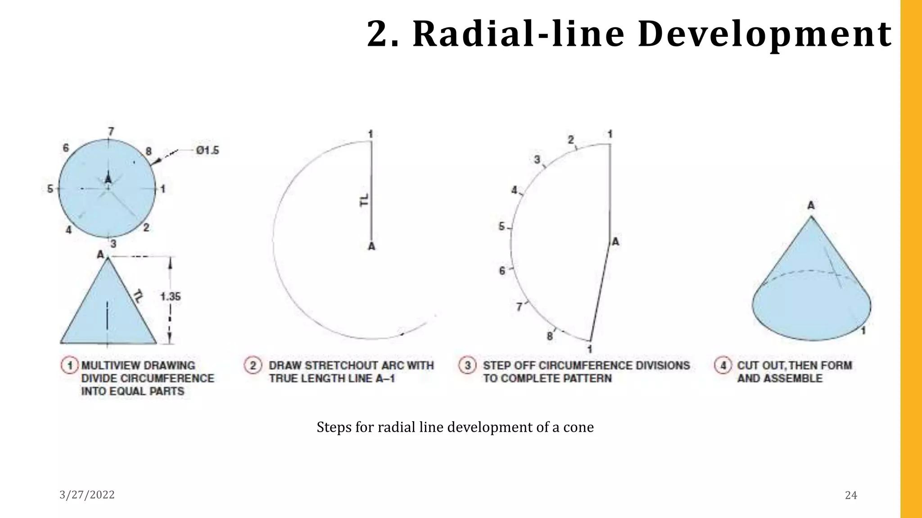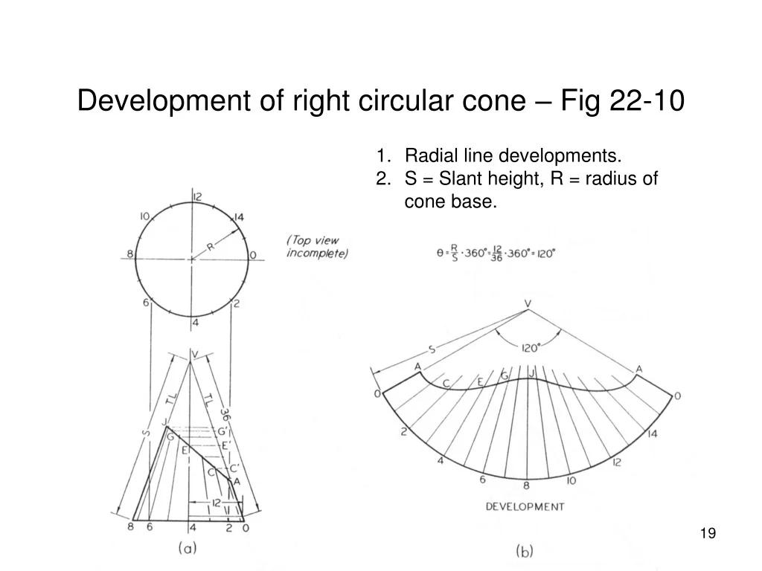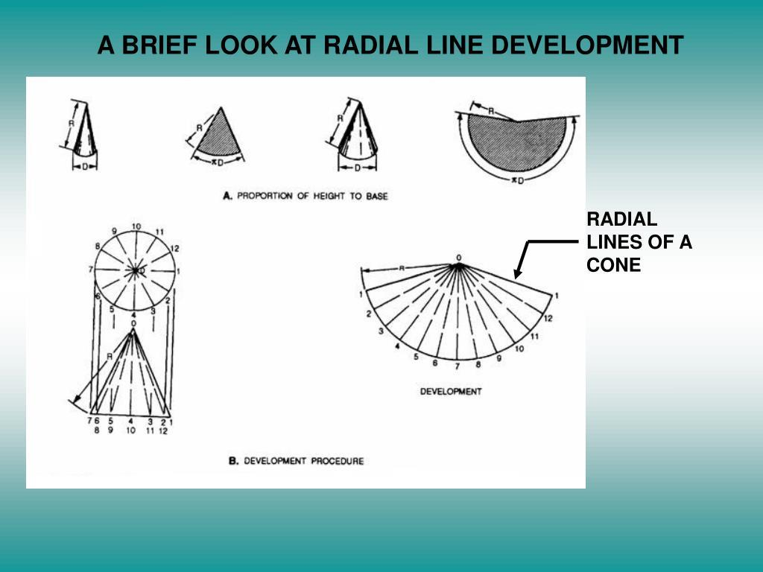
- Draw the top view of the cone as a circle.
- Draw the front view showing the apex, base diameter, height, and slant height.
- Divide the circular base into 12 or more equal sections using a protractor.
- Number the division points consecutively.
- Connect the apex to each division point in the front and top views.
- Determine the true lengths of the corresponding lateral elements.
- Select a starting radial line for the development.
- Set the compass to the required slant length.
- Draw the developed arc from the apex.
- Transfer the base circumference divisions onto the developed arc using a divider.
- Connect each transferred point to the apex using a ruler.
- Complete the radial-line development and cut out the pattern.
- Roll the developed pattern into a cone.
- Attach the circular base and verify the resulting shape.
The radial-line method is used for cone development; an oblique cone requires the true lengths of its individual lateral elements.

Method 7: Constructing a Truncated Cone (Frustum)
# Source: AI Source: Provided by: [Data Path: Persons Table -> ID Column: 1, Name_En Column: Motasem Essam] -> From: [ChatGPT] on [7/25/2026]
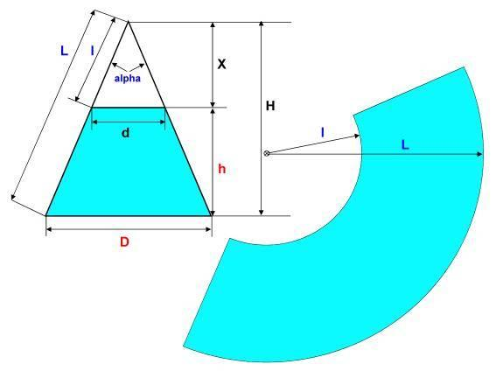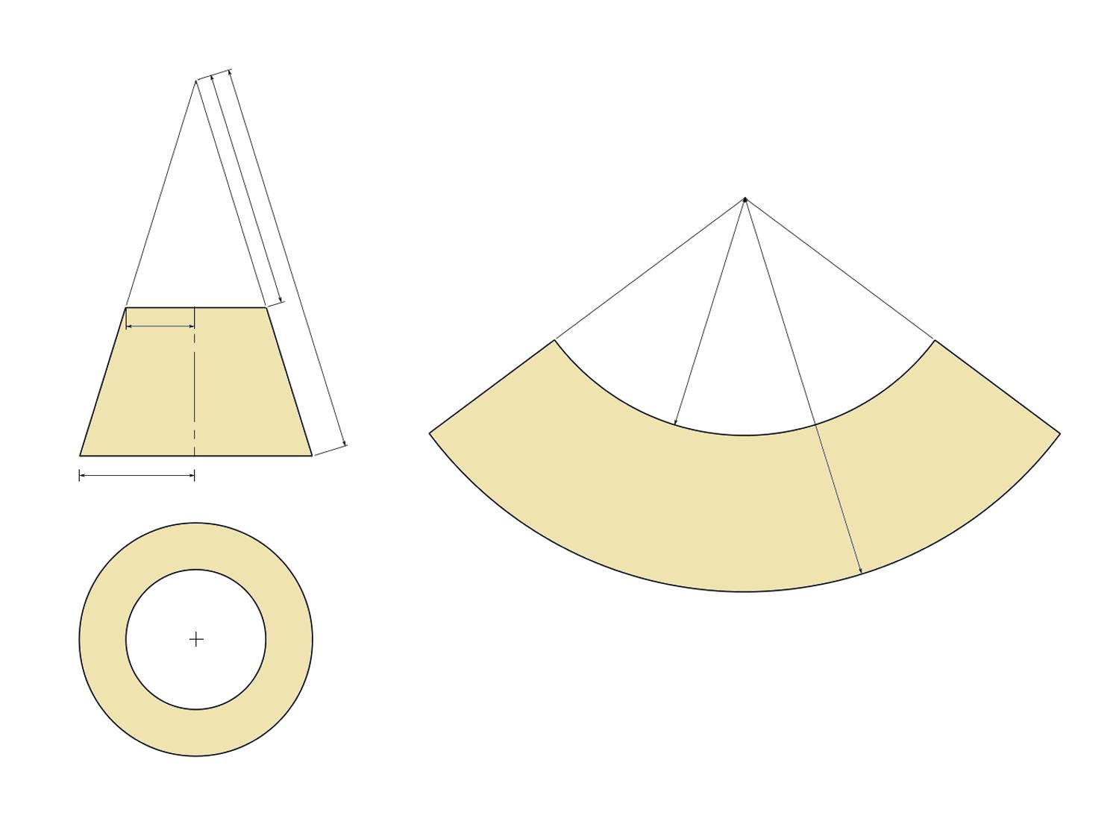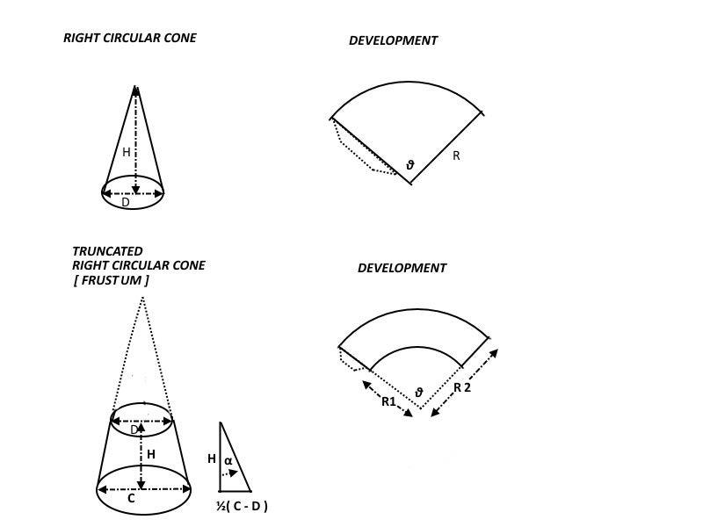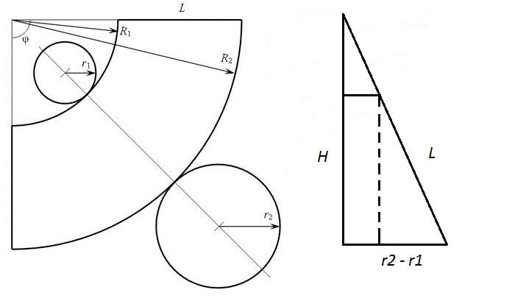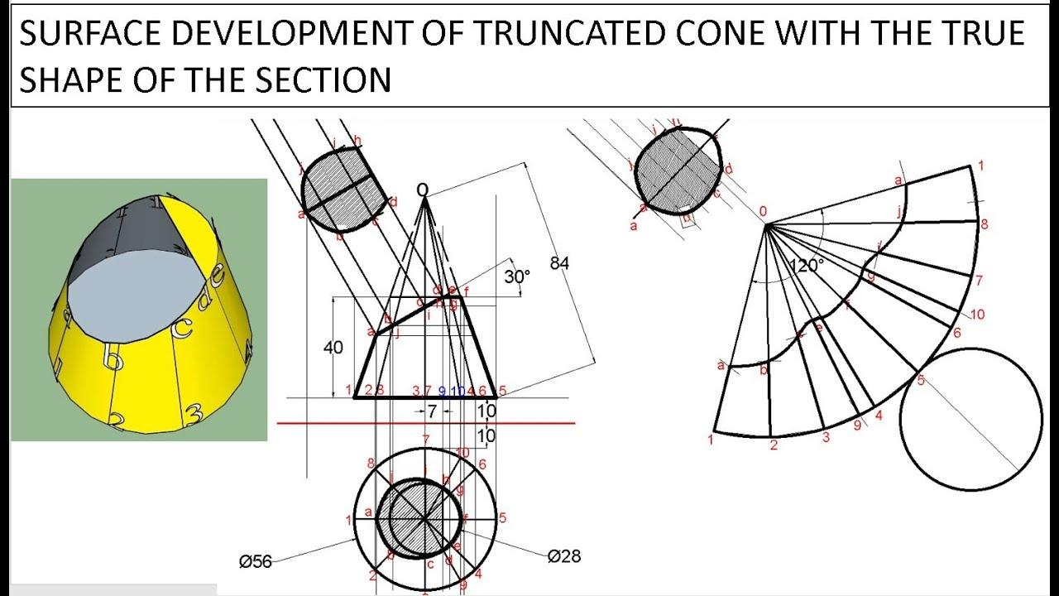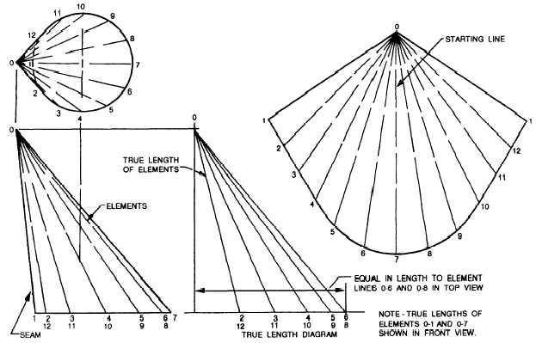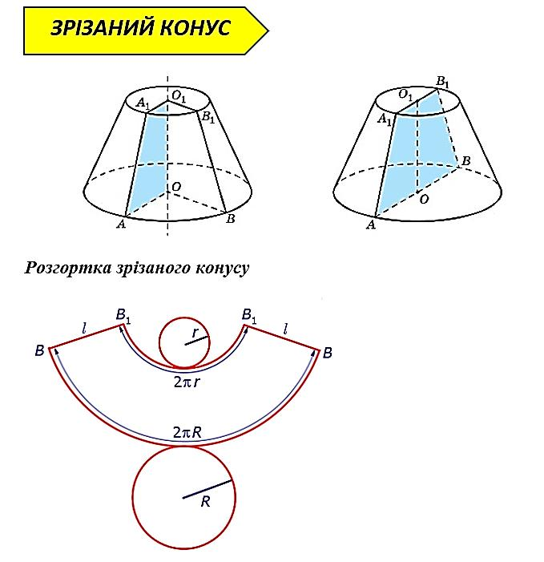
- Determine the required bottom radius $R$, top radius $r$, and perpendicular height $h$.
- Draw the front view showing the two parallel circular bases and inclined lateral boundary.
- Draw the top view showing the circular base.
- Calculate the slant height of the frustum:
$$s=\sqrt{h^{2}+(R-r)^{2}}$$
- Extend the sloping sides of the frustum until they meet at the original cone apex.
- Determine the slant distances from the apex to the larger and smaller circular boundaries.
- Draw two concentric arcs using the compass, with radii equal to those slant distances.
- Determine the sector angle from the larger base circumference:
$$θ=\frac{{360}^{°}R}{L}$$
where $L$ is the slant distance from the original apex to the larger base.
- Draw the radial boundaries using a protractor.
- Cut out the resulting annular sector and the two circular bases.
- Roll the annular sector into the frustum's lateral surface.
- Join its radial edges and attach the two circular bases.
- Verify the top radius, bottom radius, and perpendicular height.
Construction note: Methods 1–3 and 5 are suitable for a right circular cone. Methods 4 and 6 address oblique-cone construction and surface development. Method 7 covers the truncated cone (frustum).

Types of Cones
# Source: AI Source: Provided by: [Data Path: Persons Table -> ID Column: 1, Name_En Column: Motasem Essam] -> From: [ChatGPT] on [7/25/2026]

Right Circular Cone
# Source: AI Source: Provided by: [Data Path: Persons Table -> ID Column: 1, Name_En Column: Motasem Essam] -> From: [ChatGPT] on [7/25/2026]
The apex is directly above the center of the circular base. The axis is perpendicular to the base, and all straight slant segments from the apex to the base circumference have equal length.

Oblique Circular Cone
# Source: AI Source: Provided by: [Data Path: Persons Table -> ID Column: 1, Name_En Column: Motasem Essam] -> From: [ChatGPT] on [7/25/2026]
The apex is not directly above the center of the base. The axis is inclined relative to the base's perpendicular direction, so the slant distances to different points on the circumference generally differ.
For both right and oblique cones, the volume is:
$$\boxed{V=\frac{1}{3}{πr}^{2}h}$$
Here, $h$ is always the perpendicular height from the apex to the base plane.
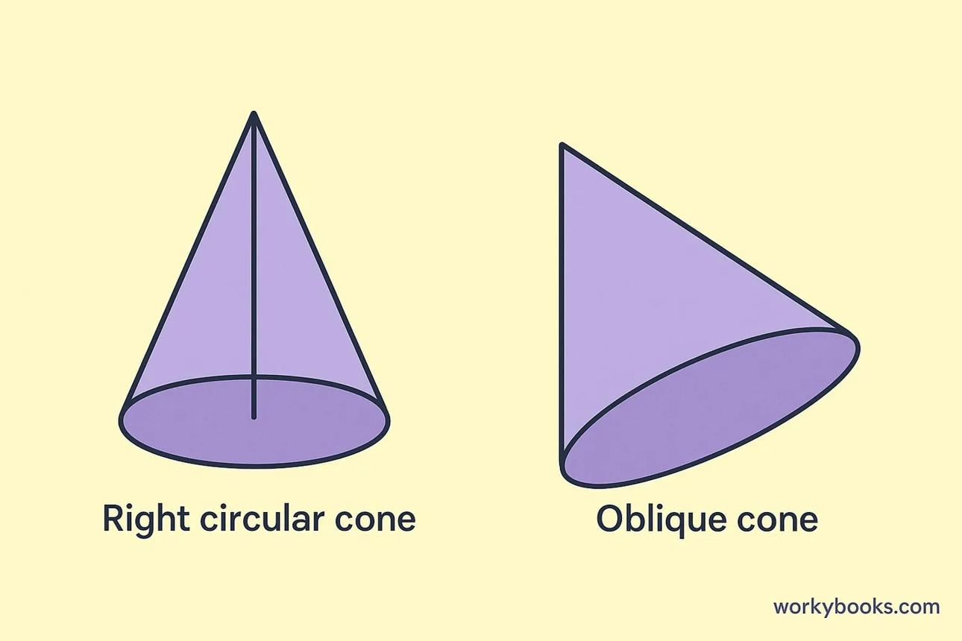

Comparison with Related Geometric Shapes
# Source: AI Source: Provided by: [Data Path: Persons Table -> ID Column: 1, Name_En Column: Motasem Essam] -> From: [ChatGPT] on [7/25/2026]
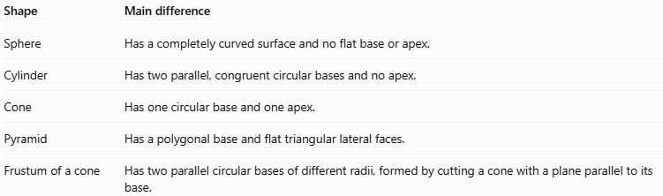
Shape | Main difference
Sphere | Has a completely curved surface and no flat base or apex.
Cylinder | Has two parallel, congruent circular bases and no apex.
Cone | Has one circular base and one apex.
Pyramid | Has a polygonal base and flat triangular lateral faces.
Frustum of a cone | Has two parallel circular bases of different radii, formed by cutting a cone with a plane parallel to its base.

Applications of Cones
# Source: AI Source: Provided by: [Data Path: Persons Table -> ID Column: 1, Name_En Column: Motasem Essam] -> From: [ChatGPT] on [7/25/2026]
- Road safety: Traffic cones mark hazards and restricted areas.
- Food packaging: Ice-cream cones and conical containers.
- Engineering: Conical funnels, hoppers, and machine components.
- Architecture: Pointed roofs and decorative structures.
- Mathematics: Studying volume, surface area, cross-sections, and geometric nets.
- Physics: Modeling light beams, waves, and fields with conical shapes.

Key Points
# Source: AI Source: Provided by: [Data Path: Persons Table -> ID Column: 1, Name_En Column: Motasem Essam] -> From: [ChatGPT] on [7/25/2026]
- A cone has one circular base, one curved lateral surface, and one apex.
- The perpendicular height differs from the slant height.
- For a right circular cone, $l^{2}=r^{2}+h^{2}$.
- The volume is $V=\frac{1}{3}{πr}^{2}h$.
- The curved surface area is $A_{L}=πrl$.
- The total surface area of a closed cone is $A_{T}=πr\left(l+r\right)$.
- A cone's net consists of a circular base and a circular sector.
- An oblique cone uses the same volume formula, but its slant distances are generally unequal.

Conclusion
# Source: AI Source: Provided by: [Data Path: Persons Table -> ID Column: 1, Name_En Column: Motasem Essam] -> From: [ChatGPT] on [7/25/2026]
A cone is a fundamental solid with a curved surface that tapers from a circular base to an apex. Its volume depends on the base radius and perpendicular height, while its curved surface area depends on the radius and slant height. Understanding the distinction between right and oblique cones helps ensure that the correct geometric relationships are used.

